Accessing your REDCap Reports for BASIC
- Go to https://redcap.healthlnk.org/index.php and log in with your username and password. Contact ellie.suse@northwestern.edu if you need an account created or do not know your username or password
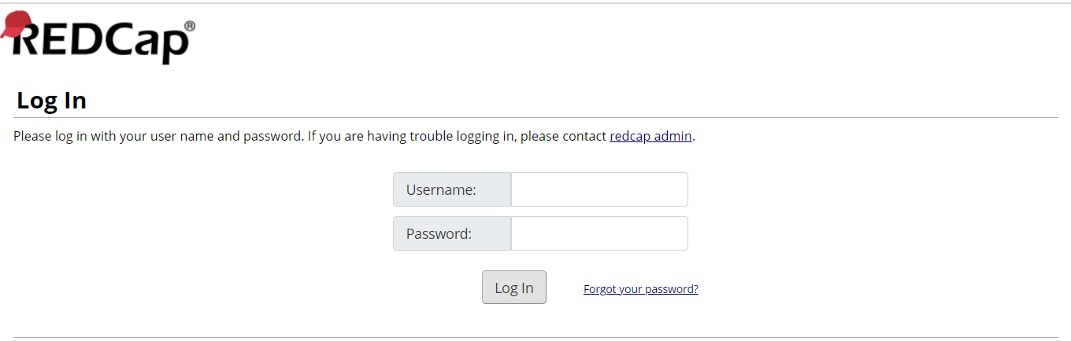
- Go to your BASIC Patient or Hospital Data form
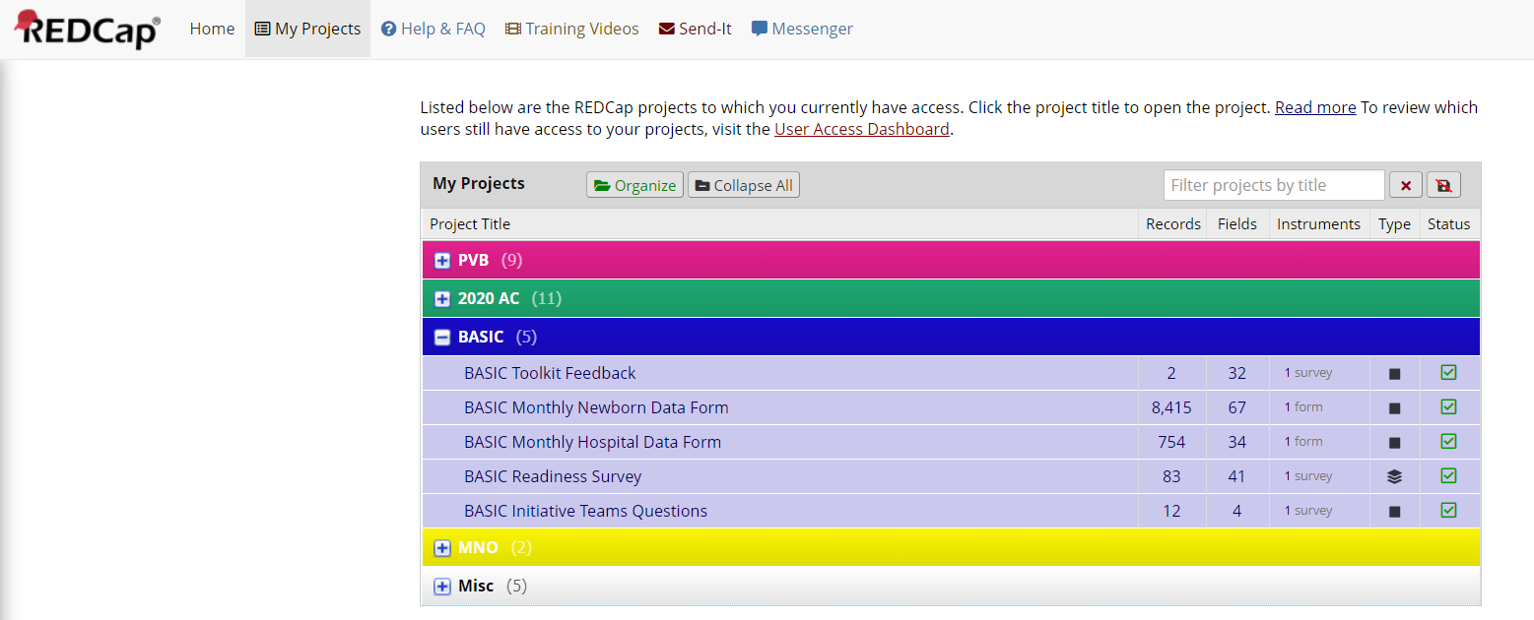
- Go to Reports on the left hand side
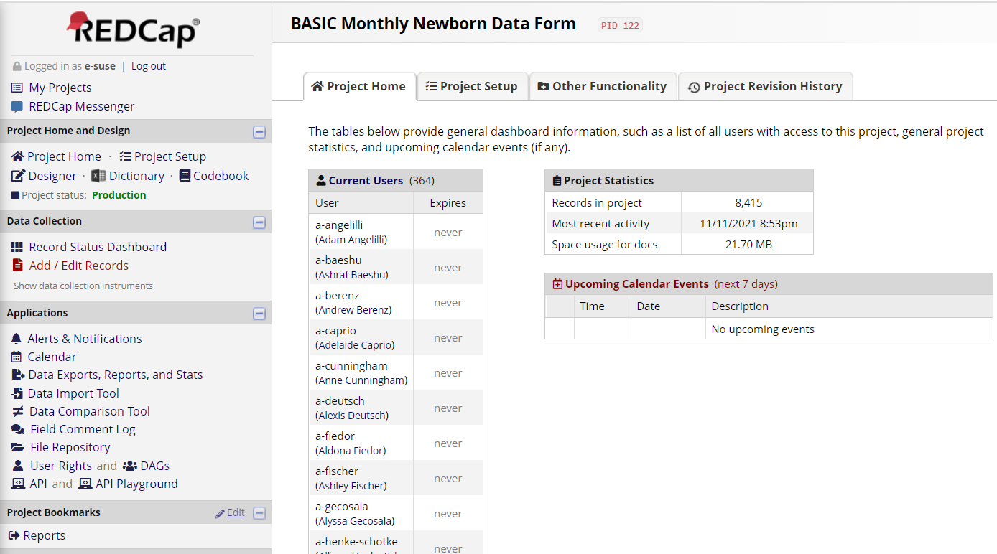
- Enter Your 3-digit Hospital ID:
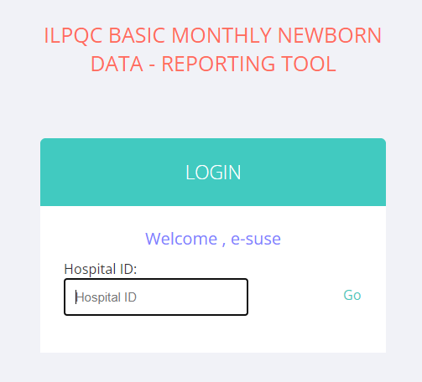
- Review the11 Patient level and 19 Hospital Level reports.
  - Patient Level Reports: For the patient level reports you can toggle between gestational weeks as well as compare yourself to the collaborative average for each measure.
  - Hospital Level Reports: Staked bar charts show what percent of the collaborative has not started working on the structure measure (red), is working on getting the structure measure in place (yellow), or has structure measure in place (green).
