Neonatal Peripheral Blood Culture Collection Checklist
Blood Culture Draw Criteria
Optimally, the blood culture should be drawn prior to the administration of antibiotics.
Note: this is a 2-person procedure.
Supplies Needed
Printed patient label for blood culture bottle Pediatric blood culture bottled
Alcohol swabs Chlorhexidine swabs
Clean gloves Laboratory biohazard transport bag
Butterfly needle 3-5 mL syringe
Gauze pads bandage or paper tape
Tourniquet
Step by Step Procedure
- Gather supplies and prepare a clean work surface.
- Perform hand hygiene and don clean gloves.
- Apply tourniquet 1 inches above intended insertion site and assess infant’s veins. Do not leave tourniquet on for more than one minute.
- Once a proper vein has been selected, remove tourniquet.
- Clean the venipuncture site with chlorhexidine for 30 seconds. Scrub the area using a back and forth motion. Allow to air dry for 30 seconds. Do NOT fan or blow on the site. Do NOT touch the intended venipuncture site after preparation.
- Prepare butterfly needle with 5 mL syringe attached.
- Prepare blood culture bottle:
  - Check expiration date.
  - Remove cap & wipe off the septum of bottle with an alcohol pad for 10 seconds. (Do not use chlorhexidine).
  - Rest the alcohol pad on top of the bottle prior to inoculation to avoid airborne contaminants.
- Reapply tourniquet.
- Position needle with bevel up.
- Immobilize vein by pressing 1” to 2” below the venipuncture site with your thumb and drawing the skin taut.
- Insert needle quickly and smoothly at a 25-30 angle through the skin.
- Collect approximately 5 mL of blood.
- After drawing the samples, remove the tourniquet, place a gauze over the puncture site, and activate the needle safety device prior to removing the needle.
- Attach a blunt needle to the syringe.
- Remove alcohol pad from bottle and transfer the blood into the bottle.
- Invert bottle 8-10 times to mix sample.
- Apply pressure to the puncture site until bleeding stops. Apply gauze and tape or bandage.
- Discard needle in sharps container and garbage into the garbage receptacle.
- Remove gloves and perform hand hygiene.
- Label bottle at the bedside (date, time, site of draw- R or L). Place bottle in biohazard bag and send to lab.
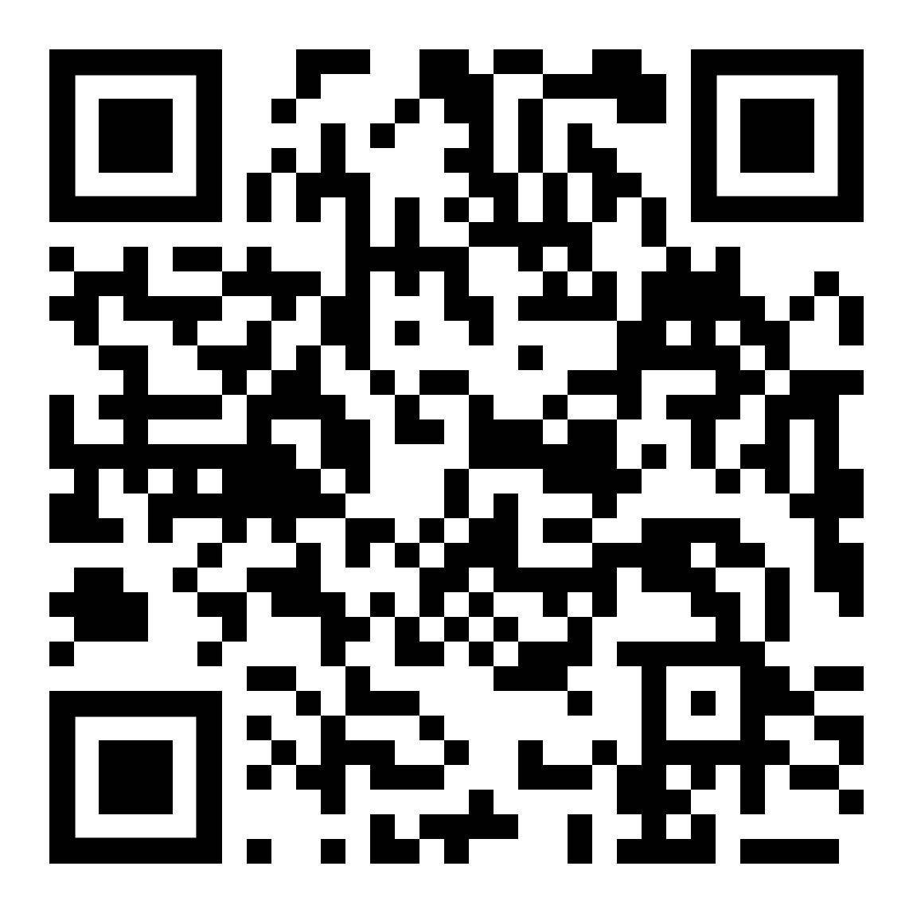
Watch the process on you tube: Click on the link or use the QR code
https://www.youtube.com/watch?v=IL3jAW1Kk9c

