What: A quick survey that provides unique opportunity for our team to gain a deeper understanding of our current labor & delivery clinical culture. All entries will remain anonymous.
Complete your Labor Culture Survey today!
Calling ALL Labor & Delivery Clinicians and Staff:
Who: All nurses, doctors, midwives and other clinical staff should participate and complete the survey.
When: Complete the survey between Date and Date
How: Follow the directions below to complete your survey now in 10-15 minutes. Remember all survey entries will remain anonymous.

Complete your survey now:

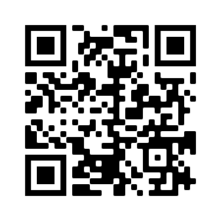
Step 1: Scan the QR code
Step 2: Choose your hospital from the drop-down menu

Step 3: Answer the questions and submit

*This study has been approved by the NSUHS IRB; EH #19-126
Questions? Please contact:
ILQPC Central: info@ilpqc.org
Francesca Carlock: FCarlock@northshore.org
Dr. Emily White VanGompel: EWhiteVangompel@northshore.org

