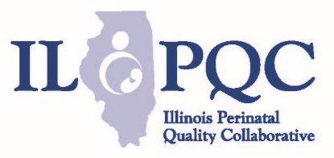
MNO-OB Mothers with OUD

Missed Opportunities Review Form

- Was patient receiving Medication Assisted Treatment (MAT) prenatally or by delivery discharge?
- Yes
- No
If no, why? Please select all that apply
- OUD was not identified prior to delivery
- Patient’s OUD was identified, but was not counseled (SBIRT) and/or navigated to care
- Patient was identified and received SBIRT counseling, received SUD support services, but declined MAT
- Patient was identified and received SBIRT counseling, declined MAT and Behavioral Health Counseling/Recovery Services
- Providers/staff didn’t document
- MAT treatment providers not available?
- Unknown
If no MAT prenatally or by delivery discharge, please select all the steps in the OUD protocol that were completed.
- Patient was screened for OUD using a validated screening tool prenatally and on L&D
- Patient was counseled (SBIRT) on treatment options and SUD support services prenatally or during delivery admission
- Patient was navigated to MAT/Behavioral Health Counseling/Recovery Services prenatally or during delivery admission
- Patient received Behavioral Health Counseling/Recovery Services
- OUD clinical care checklist in chart
- Prenatal pediatric consult to discuss NAS

- Does patient have a completed OUD Clinical Care Checklist (completed prenatally or during delivery admission)?
Yes
No

If no, why? Please select all that apply
- OUD not identified by clinical care team
- Providers/staff didn’t have access to checklist?
- Provider/staff didn’t know they needed to complete checklist for patients with OUD?
- Providers/staff didn’t document care received?
- Checklist was in chart but not completed?

- Please select all items in the OUD Clinical Care Checklist that were completed prenatally or during delivery admission.
- Narcan counseling and prescription offered and documented
- Contraception Counseling and Plan and documented
- Behavioral Health/Social Work Consult provided and documented
- Referral to BH Services/Recovery Services / MAT provided and documented
- Hepatitis C screening and provided and documented
- OUD/NAS Neonatal/Pediatric consult provided and documented
- Education on OUD and NAS Newborn Care provided and documented

