Introduction: This is a tool for Illinois birthing and children’s hospitals to facilitate accurate reporting of diagnoses, symptoms, and substance exposures of Neonatal Abstinence Syndrome (NAS); newborn withdrawal symptoms, including from therapeutic use of drugs in newborn; and substance exposure causing neurobehavioral abnormalities in the Adverse Pregnancy Outcomes Reporting System (APORS).

Goal:  **Report consistent statewide data on NAS across birthing hospitals to identify and refer infants who require special services and ensure accurate population level data on the problem of NAS.** The Illinois Perinatal Quality Collaborative’s (ILPQC) Mothers and Newborns affected by Opioids (MNO) Neonatal Initiative facilitates hospital improvement efforts in the standardized identification and assessment of NAS signs and symptoms for Substance-Exposed Newborns (SENs). **The following table links identification of SENs to accurate reporting in APORS.**

|  |  |  |
| --- | --- | --- |
| Standardized Identification and Reporting of NAS Signs  and Symptoms for Opioid or other Substance-Exposed Newborns (SENs) | | |
| *A: ILPQC/IDPH: How was Substance-Exposed Newborn Identified?* | ***B: APORS: Did the newborn have symptoms associated with the substance exposure?*** | ***C: APORS: What is the diagnosis and corresponding substance exposure*** |
| SEN identified via:   * Mothers who screened positive for OUD prenatally or on L&D, prior to delivery identified; * Mothers who present to L&D or Birthing Center for evaluation or urgent antepartum assessment (via IDPH NAS AC Decision Tree) | Yes, infant has symptoms associated with substance exposure other than alcohol or marijuana | * Neonatal withdrawal/abstinence syndrome (NAS)* * Withdrawal from therapeutic use of drugs in newborn * Neonatal withdrawal symptoms (NAS not diagnosed) * Substance exposure causing neurobehavioral abnormality   (choose 1) |
| Yes, infant has symptoms associated with alcohol exposure | * Fetal alcohol syndrome * Alcohol exposure affecting infant§ (Choose 1) |
| No, infant has substance exposure (other than alcohol and marijuana), but no symptoms | * Positive neonatal or maternal toxicology screen†, or disclosure of illicit drug use |

*\*Neonatal Abstinence Syndrome refers to the collection of signs and symptoms that occur when a newborn prenatally exposed to prescribed, diverted, or illicit opiates experiences opioid withdrawal. This syndrome is primarily characterized by irritability, tremors, feeding problems, vomiting, diarrhea, sweating, and, in some cases, seizures. (IDPH NAS Advisory Committee Definition)*

*§ Alcohol exposure affecting infant does not meet the APORS case definition, but could be included on a report based on a reportable condition.*

*† Positive neonatal or maternal toxicology screen attributable to drugs administered during labor and delivery are not reportable*

**Standardizing Documentation of Newborn Substance Exposure and Symptoms:**

After a substance exposed newborn has been discharged, the next step is to accurately document this information in the IVRS birth certificate and submit a case to the IL APORS system.

* APORS data can be reported via an electronic or paper form. An APORS reporter at your hospital will manually generate an electronic or paper case.
* In some instances, APORS will generate automatic cases when certain criteria are met as input in the birth certificate/IVRS (i.e. <31 completed weeks gestational age, triplet or higher order birth, congenital anomaly, death before birth certificate is filed).
* Substance exposure and NAS do not generate automatic APORS cases, so your hospital’s APORS reporter will need to manually generate an APORS case (unless other criteria are met).

**APORS Electronic Form**

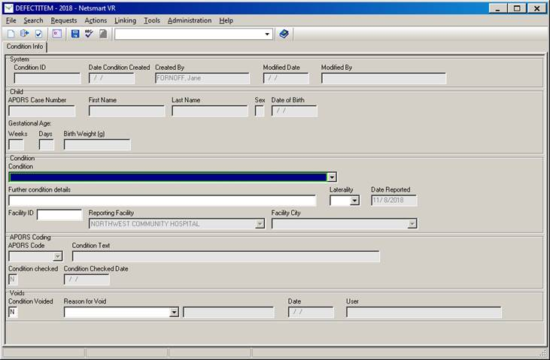

* **Condition (including congenital anomalies):** Enter diagnoses into this section. In regards to newborn substance exposure, please refer to columns B – C on the reverse to accurately report newborn diagnoses
* **Further condition details:** Enter the drug toxicities (substance exposures) in this section.

**APORS Paper Form**

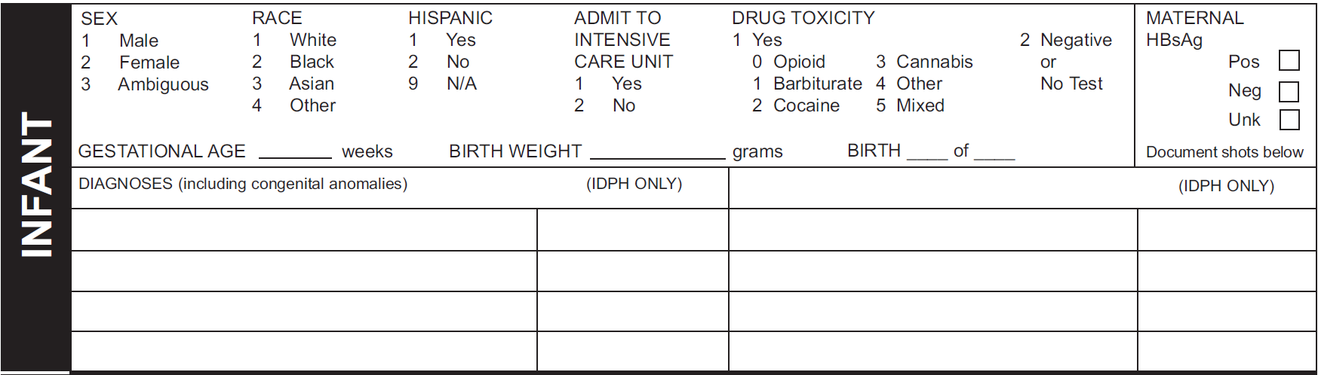

* **Diagnoses (including congenital anomalies):** Enter diagnoses into this section. In regards to newborn substance exposure, please refer to columns B – C on the reverse to accurately report newborn diagnoses
* **Drug Toxicity (Substance Exposures):** Enter the drug toxicities (substance exposures) in this section. Circle ‘0’ for Opioid exposures.

**APORS General Data Reporting Workflow for Hospital Teams**

Mother delivers baby

Clinical birth data is entered by clinical team

Birth certificate clerk abstracts data from clinical reports and enters into IVRS/BC

Does infant meet one or more APORS criteria?

Infant discharged

No

Yes

**Electronic APORS Report Automatically Generated**

* <31 weeks gestation
* Triplet/higher birth order
* Congenital anomaly
* Death before completion of birth certificate

**Electronic APORS Report Manually Generated**

APORS reporter audits chart for APORS criteria

**Paper APORS Report Manually Generated**

IVRS queue for automatic & manually generated electronic APORS reminders

APORS completed and submitted electronically via APORS website

Paper APORS report completed and submitted to APORS

*\*Note: Submit APORS electronic or paper report within 7 days of infant discharge*

**APORS Data Reporting Workflow for Substance-Exposed Newborns for Hospital Teams**

*\*Note: Submit APORS electronic or paper report within 7 days of infant discharge*

Does infant have symptoms associated with substance exposure?

Yes, infant has symptoms associated with substance exposure other than alcohol

APORS completed and submitted electronically via APORS website or paper to APORS

Report the FAS

Yes, infant has FAS

No. Alcohol exposure is not a reportable condition

Does infant have Fetal Alcohol Syndrome?

**Report the diagnosis:**

* Positive neonatal or maternal toxicology screen, or disclosure of illicit drug use

No, infant has substance exposure (other than marijuana and alcohol), but no symptoms

Report the drug exposures

**Report the diagnosis:**

* Neonatal withdrawal/abstinence syndrome (NAS)*
* Withdrawal from therapeutic use of drugs in newborn
* Neonatal withdrawal symptoms (NAS not diagnosed)
* Substance exposure causing neurobehavioral abnormality

Paper APORS report completed and submitted to APORS

APORS reporter audits chart for APORS criteria

**Paper APORS Report Manually Generated**