Adobe Connect Instructions

- Log on to your computer, connected to the internet. (If you have access to a wired connection, that is preferred.)

- Open your web browser and go to the following link:
http://northwesternuniversity.adobeconnect.com/r1tm91b1fjd/

- On the main screen, log in as a Guest by typing in your name and selecting ‘enter room’ as shown below: 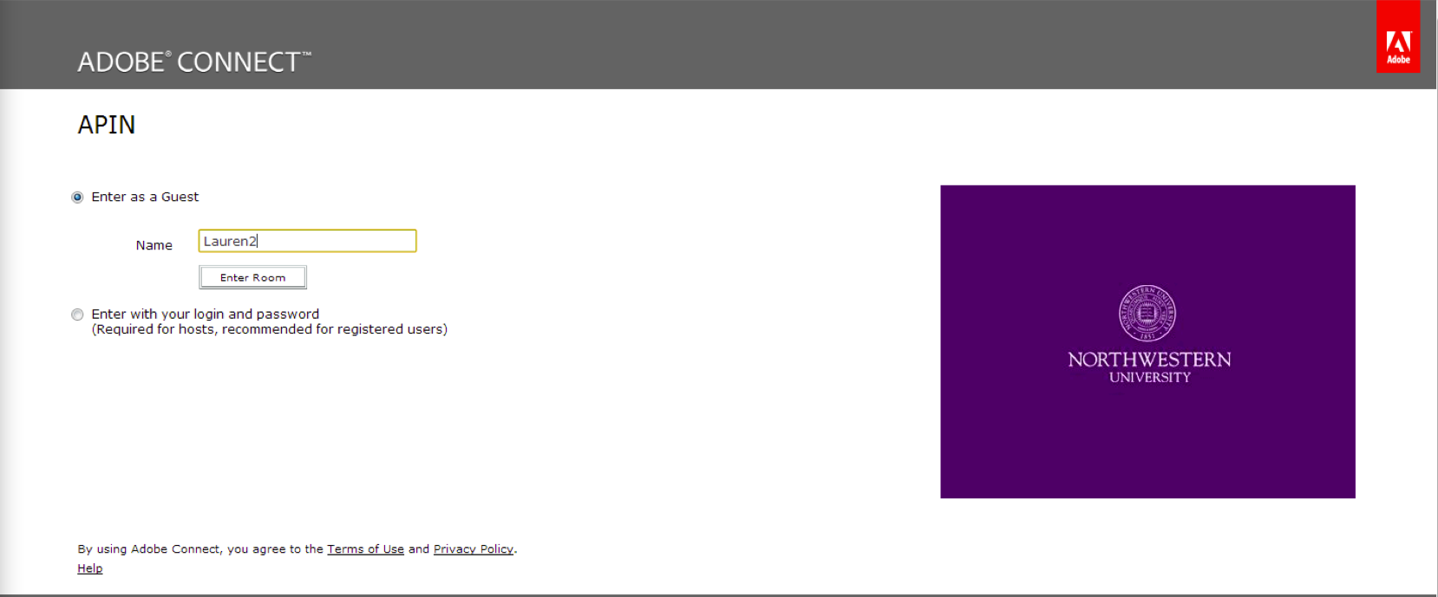

- We will not be using Adobe Connect for audio or video. Dial in to the conference line for audio:
  - 1-877-860-3058
  - Participant Passcode: 850 207 6731

Additional Features:
- If you want to comment via Chat, enter your messages in the ‘Chat’ Screen for everyone to see, as shown below:
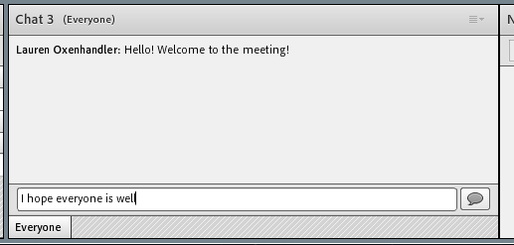

- You can send private Chat messages to the host(s) of the meeting via the ‘Attendees’ area. Select ‘Start Private Chat’ as shown below:
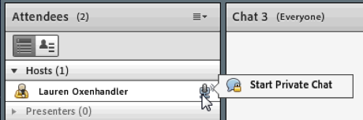

- The host(s) can be taking important Notes in the Notes section for all participants to see.
- If you have any files to share with the group, please let the host(s) know.

