Please use these resources to let others know what is happening with the We Promote IL Mamas Twitter Page (@PromoteILmamas), a product of the CASE Committee within the Illinois Maternal Health Task Force.

Toolkit Table of Contents
The Details 1
Email and Newsletter Content 2
Social Media Content 2
Twitter Sample Posts 2
Graphics 4

The Details

The launch of this Twitter Page and its content development is a product of the Communications Workgroup within the Community Access, Systems Equity, and Education (CASE) Committee of the Illinois Maternal Health Task Force (ILMHTF). This social media campaign contributes to the accomplishment of an I PROMOTE-IL 2022 Action Step to create and disseminate public education materials for pregnant and birthing persons, families, and communities on key pregnancy and postpartum issues. It is a collaborative effort, and effective dissemination of the campaign’s materials relies heavily on the active network of personal and professional partnerships of the Illinois Maternal Health Task Force.

The CASE Committee’s Communications workgroup will develop materials for a public education campaign on the importance of postpartum care. This campaign will include information on the following topics:
- Maternal Urgent Warning Signs;
- Medicaid coverage for two preventative postpartum visits;
- Seeking care in emergency departments while pregnant or postpartum;
- Community birthing options in areas affected by hospital closures;
- COVID-19 vaccination for pregnant and breastfeeding persons;
- Utilizing telehealth for prenatal care visits.
- 12-month postpartum Medicaid expansion in Illinois that was approved by HHS through a waiver process in 2021;
- #Communitybirthsurvey with Holistic Birth Collective
- Press release template, radio community segment and submission options

This toolkit contains the social media dissemination plan for the distribution of this information.

Email and Newsletter Content
Subject line: We Promote IL Mamas: COVID-19 while Pregnant and Breastfeeding

Announcing the inauguration of a new project, the COVID-19 Campaign for Pregnant and Breastfeeding Moms! The purpose of this project is to address the concerns/perspectives of unvaccinated pregnant persons, educate pregnant and postpartum persons on the benefits and risks of getting a COVID-19 vaccine, and provide resources for support persons in favor of obtaining the vaccine.

This campaign content is a product of the Communications Workgroup within the Community Access, Systems Equity, and Education (CASE) Committee of the Illinois Maternal Health Task Force (ILMHTF). It is a collaborative effort, and its effective dissemination relies heavily on the active network of personal and professional partnerships of the IL Maternal Health Task Force.
If you have a Twitter account, please support the campaign by reposting the messages outlined in this toolkit. If you are new to Twitter, please follow the steps to create a Twitter account using this link, follow the Twitter page @PromoteILmamas, and retweet these important messages so that birthing persons and supporters in your network can view them as well. Thank you in advance for sharing this information widely.

For more information, contact ipromote-il@uic.edu.

Social Media Content
Follow & Tag @PromoteILmamas on Twitter
- We Promote IL Mamas (Twitter) @PromoteILmamas
- HRSA social media (FB, Twitter, IG) @hrsagov

Quick Links:
- Twitter: @PromoteILmamas @HRSAgov

Like social media posts with #pregnantandvaccinated #breastfeedingandboosted

Find a Twitter Character Counter tool here, to help craft your own posts.
Find guidance on the best times to post on social media sites here.

Twitter Sample Posts
- Getting the COVID-19 vaccine is an important decision for pregnant and breastfeeding mamas! Be informed about your choices. Talk to your healthcare provider about your options. Learn more here: 21_Everthrive_Pregnant-People-Fact-Sheet_V001.pdf (everthriveil.org)
- Getting vaccinated and continuing to give breast milk to your baby is the most effective way to protect your baby against COVID-19. #WePromoteILmamas Learn more here: Common Myths About the COVID-19 Vaccine During Pregnancy (whattoexpect.com)
- If you’ve wondered about COVID-19 vaccines and fertility, you are not alone! Learn more from this fertility doctor: Top Reasons to Not Get the COVID Vaccine: A Fertility Doctor Reviews the Science and Latest Updates - YouTube
- Nobody wants to talk about vaccines these days! Check out these tips for talking to your loved ones: Tips for talking to your loved ones about the COVID-19 vaccine (chicago.gov)
- Find an Illinois COVID-19 vaccine location near you using this link: Vaccination Locations (illinois.gov)
- Myth #1: The COVID-19 vaccine can cause complications in pregnant people and harm the baby! This is not true. Research has shown that the risk for complications in pregnant people is the same with or without the COVID-19 vaccine. 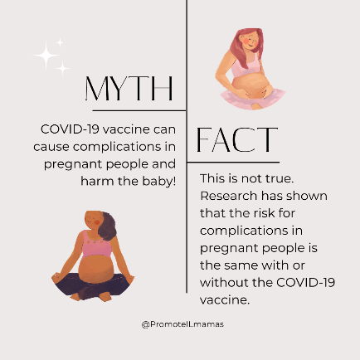
- Myth #2: The COVID-19 vaccine was developed quickly and was not thoroughly tested. This is not true! The FDA tracks 5 phases of development for all vaccines, including the COVID-19 vaccine, before approving them.
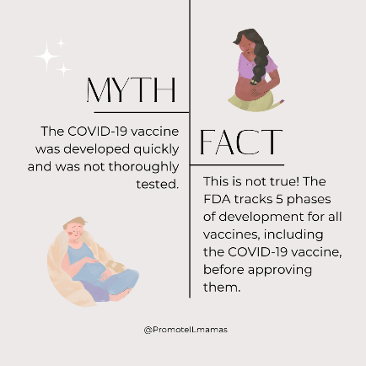
- Myth #3: The Vaccine is experimental. This is false! The FDA officially approved the Pfizer and Moderna vaccines. The benefits are proven to outweigh the risks.
- 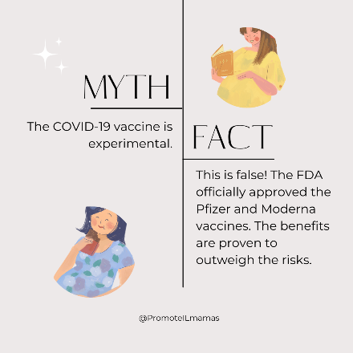
- Myth #4: The COVID vaccine can give you COVID. This is not true! None of the vaccines offer an active or contagious form of the virus, only the pieces to help your body build the right antibodies.
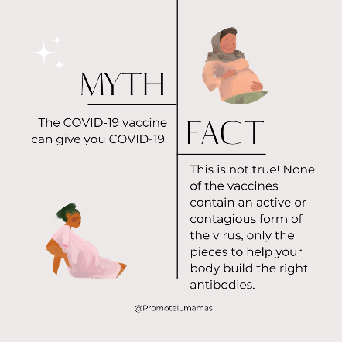
- Myth #5: The COVID vaccine can change your DNA since it uses a new method. This is not true! The mRNA vaccines cannot enter the nucleus of the cell, where your DNA lives. How mRNA COVID-19 Vaccines Work (cdc.gov)
- 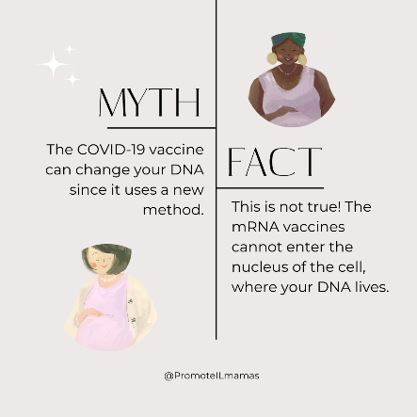

Graphics
Find images sized for social media (in JPG formats) here
Find PDF fliers with clickable links here and here.

