 **Think Cultural Health Information Sheet**

**Description:**

Launched in 2004 and sponsored by the Office of Minority Health, Think Cultural Health is a website created to provide resources and continuing education opportunities for health professionals and healthcare organizations to advance health equity, improve healthcare quality, and eliminate healthcare disparities. Think Cultural Health details Culturally and Linguistically Appropriate Services (CLAS) in maternal health care in a 4-module program to support maternal health care providers in advancing health equity, improving quality, and reducing disparities. It is one of the 2 equity and bias trainings recommended by ILPQC for hospital teams to meet Birth Equity Driver 4 strategies.

**Education Content available:**

Program Contents: Introduction, Pretest, 4 modules, Posttest, & Course Evaluation. Each module incorporates self-reflective questions, “tell me more” options, case study, quiz, and next steps with a list of related resources. Glossary, Reference List, and Resource Library are also available.

Module 1, **An introduction to CLAS in maternal health care**, examines the role of CLAS in improving quality and eliminating disparities in maternal health care. This module focuses on the following concepts:

* CLAS and healthcare quality
* Cultural competency and cultural humility
* Racism and maternal health
  + Maternal health disparities
  + Social Determinants of Health
  + Institutionalized racism
  + Weathering

Module 2, **Self-awareness**, helps participants become more aware of their beliefs and values, as well as their privilege, power, bias, and stereotypes. The following concepts are highlighted:

* Social & cultural identity
  + Dominant/non-dominant social groups
  + Privilege
  + Power
* Implicit bias and stereotyping
  + Impact on clinical encounters
  + Awareness
  + Strategies to address biases and stereotypes

Module 3, **Awareness of a patient’s cultural identity**, presents the how and why of getting to know a patient’s cultural identity. Concepts highlighted include:

* Strategy of individuation
* Intersectionality
* Microaggressions
* Perceived racial discrimination
* History of racism
* Cultural humility

Module 4, **Providing CLAS in maternal health care**, explores ways to deliver respectful, compassionate, high quality care that responds to patients’ experiences, values, beliefs, and preferences. This module focuses on the following concepts:

* Review of cultural competency and cultural humility
* Person-centered care strategies
  + Effective communication strategies
  + Partnership building
  + Shared decision-making

**Access Information:**

Login or register at the Think Cultural Health [website](https://thinkculturalhealth.hhs.gov/maternal-health-care/login)

Choose Maternal Health Care Providers - Culturally and Linguistically Appropriate Services (CLAS) in Maternal Health Care program

Login, Read the Overview, Choose appropriate credit information & click Continue

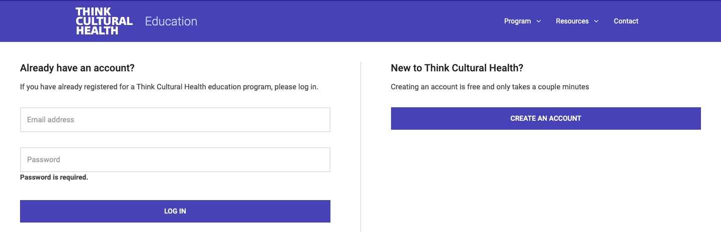

Implementation strategies for the QI team

* Idea 1
* Idea 2
* Idea 3