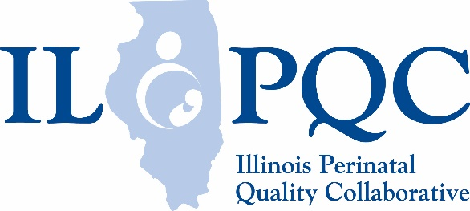
patient sticker
MNO Nursing Workflow
When an obstetric patient screens positive for Opioid Use Disorder (OUD) during an L&D admission, an MNO Folder (stored on L&D/triage) should be obtained by the patient’s nurse. The folder should have (1) OUD/SBIRT Clinical Algorithm and the OUD Clinical Care Checklist to give to the OB provider to complete, (2) Naloxone (Narcan ®) quick start guide to help providers complete Naloxone counseling / prescription and (3) has MNO patient education material to give to the patient to provide information on OUD / Neonatal Abstinence Syndrome (NAS) and the importance of moms engaging in the care of the opioid exposed newborn with breastfeeding, skin to skin, and rooming in. The L&D nurse should hand off and review this form with the pp nurse.

The patient’s nurse should work with the rest of the obstetric clinical team to make sure the OUD Clinical Algorithm and OUD Checklists are completed prior to discharge. Reminding the clinical team that OUD is the leading cause of maternal death in Illinois may help the team understand why these clinical steps matter.

Labor and Delivery/Admission Nurse:
√
 | Nursing task | Comments/Notes
 | Report positive OUD screen to OB provider and give the OB provider the OUD/SBIRT Clinical Care Algorithm and OUD Clinical Care Checklist to complete, remind them these items need to be completed for every patient with OUD during the hospital admission.
 | Request a neonatology consult for positive OUD screen to counsel on NAS, and how moms engage in opioid exposed newborn care.
 | Confirm Hep C, HIV, Hep B screening completed or draw appropriate lab orders as indicated.
 | Ensure patient has received the OUD/NAS education materials in the MNO folder, review materials with the patient and document.
 | Confirm OB Provider assessed patient’s readiness for Medicated Assisted Treatment (MAT) and plan for treatment is documented before hospital discharge. Remind providers that help with clinical management of OUD / MAT is available through the IL Doc Assist Hotline 1-866-986-2778 with a free addiction med phone consult.
 | Confirm the patient is linked to behavioral health services / recovery treatment program and has follow up or work with a social work consult to confirm a warm hand off and close follow up to establish linkage to services before discharge. Local OUD treatment program options are available through the IL OUD Hotline 1-833-2-FINDHELP.
 | Confirm the provider has the Naloxone (Narcan ®) quick start guide from the MNO folder (to assist with Naloxone counseling/prescription as a risk reduction strategy for all patients who use opioids regularly).
 | Remind all members of the care team that reducing stigma and treating patients with empathy and compassion improves outcomes for moms with OUD.
 | Handoff MNO folder and MNO nursing workflow to postpartum nurse and review completed tasks.
patient sticker

Postpartum / Delivery Discharge Nurse:
 | Nursing task | Comments/Notes
√ | Review MNO patient education material (found in the MNO folder or www.ilpqc.org website) with the patient / family and confirm understanding of important role of mom/family in the care of opioid exposed newborns including breastfeeding, skin to skin, and rooming in. Provide education on safe sleep. Document education provided.
 | Work with neonatology / pediatric team to engage and support mom / family providing non-pharmacologic care as appropriate: breastfeeding, skin to skin, rooming in, eat-sleep-console.
 | Review OUD Clinical Care Checklist with OB Provider to determine next steps for incomplete checklist elements before discharge.
 | Confirm patient’s MAT plan with the clinical team and patient’s understanding of next steps for MAT follow-up as indicated. Document appropriately.
 | Confirm Behavioral Health/Recovery Treatment Program appointment made before discharge for close postpartum follow-up.
 | Confirm Naloxone (Narcan ®) counseling has been provided by the clinical team and a prescription has been provided before discharge. If possible, encourage having the prescription filled prior to discharge. Document counseling / prescription received.
 | Confirm Hepatitis C screening completed and results provided to the patient, follow up plan established by OB for all positive screens.
 | Ensure all appropriate elements in the OUD Clinical Care Checklist are complete before discharge.
 | Confirm patient has an early postpartum follow up visit with OB for 1-2 weeks postpartum scheduled before hospital discharge.
 | Ensure the OB clinical team is in communication with neonatology / pediatrics to confirm a coordinated discharge plan checklist has been or will be completed for the newborn and make sure the patient / family is engaged in and understands the discharge plan process.
 | Remind all members of the care team that reducing stigma and treating patients with empathy and compassion improves outcomes for moms with OUD.

