**What is ESC?**

A patient and family centered approach to monitor for clinically significant neonatal abstinence syndrome (NAS) due to in-utero opioid exposure.

**Principles of ESC:**

1. Optimize the newborn’s functioning through non-pharmacologic treatment provided by parent(s) or caregiver(s).
2. Reserve medication treatment for those newborns who are unable to eat, sleep, or console despite maximal non-pharmacologic care.



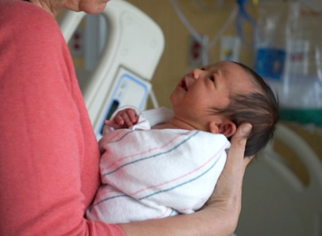

**How does the ESC Care tool compare to the Modified Finnegan** (NASS, MOTHER tool)?

* ESC focuses on the infant’s overall state using a function-based assessment rather than scoring each symptom of NAS using a numerical score-based approach.
* The duration and frequency of monitoring (after feeds every 3-4 hours) remains the same.
* Infant assessments are reported as yes/no on the ESC care tool instead of a numerical score.
* Infants are still monitored for clinical signs of withdrawal, but medication decisions will be made based on the infant’s ability to eat, sleep and console rather than their “score”.
* Full team huddles (NICU evaluation) will be called when symptoms of NAS impair eating, sleeping or consoling despite maximizing non-pharmacologic measures.
* Pharmacologic initiation, stabilization, and weaning will continue to be managed by the NICU.

**Eating**: Does the infant have poor eating due to NAS?

|  |  |
| --- | --- |
| **Yes** | **No** |
| * Infant takes more than 10min to coordinate feeding OR cannot sustain breastfeeding for 10min/ take age appropriate volume bottle feeding due to opioid withdrawal symptoms. | * Poor feeding due to prematurity, sleepiness or spittiness in first day of life, or anatomical factors preventing good latch. |
| * Unclear if poor feeding related to NAS | * Age appropriate feeding pattern |

**Sleeping**: Did the infant sleep less than 1 hour after feeding due to NAS?

|  |  |
| --- | --- |
| **Yes** | **No** |
| * Poor sleep is related to opioid withdrawal symptoms (fussiness, restlessness, increased startle, or tremors). | * Poor sleep due to withdrawal from other substances, physiologic cluster feeding, or interruptions for newborn assessments. |
| * Unclear if poor sleep is related to NAS | * Infant sleeps more than 1hr after feeds. |

**Consoling**: Is the infant unable to be consoled within 10 minutes due to NAS?

|  |  |
| --- | --- |
| **Yes** | **No** |
| * Unable to console within 10 minutes due to opioid withdrawal symptoms despite use of Consoling Support Interventions. | * Lack of consoling due to other factors including missed hunger cues and circumcision pain. |
| * Unclear if consoling difficulties related to NAS | * Infant consoles on own or within 10 minutes. |

**Non-pharmacologic treatment:** parents/caregivers are the best therapy for the infant.

|  |  |
| --- | --- |
| * Rooming-in: be with the baby as much as possible * Skin-to-skin: maximize when caregivers are awake and alert * Swaddle/Cuddle infant * Calm room: lights low, volume quiet | * Encourage breastfeeding unless contraindicated * Feed at early hunger cues * Sucking: offer finger or pacifier if infant still needs to suck after a feed * Limit visitors: no more than 1-2 at a time |