Think Cultural Health Information Sheet
Description:
Sponsored by the Office of Minority Health, Think Cultural Health is a website created to provide resources and continuing education opportunities for health professionals and healthcare organizations to advance health equity, improve healthcare quality, and eliminate healthcare disparities. This program details Culturally and Linguistically Appropriate Services (CLAS) in maternal health care in a 4-module program to support maternal health care providers in advancing health equity, improving quality, and reducing disparities. ILPQC has identified this training as one of the free and scalable maternal health focused equity and bias e-module trainings currently available.
Education Content available: Introduction, Pretest, 4 modules, Posttest, & Evaluation
- Module 1: An introduction to CLAS in maternal health care
- Module 2: Self-awareness
- Module 3: Awareness of a patient’s cultural identity
- Module 4: Providing CLAS in maternal health care

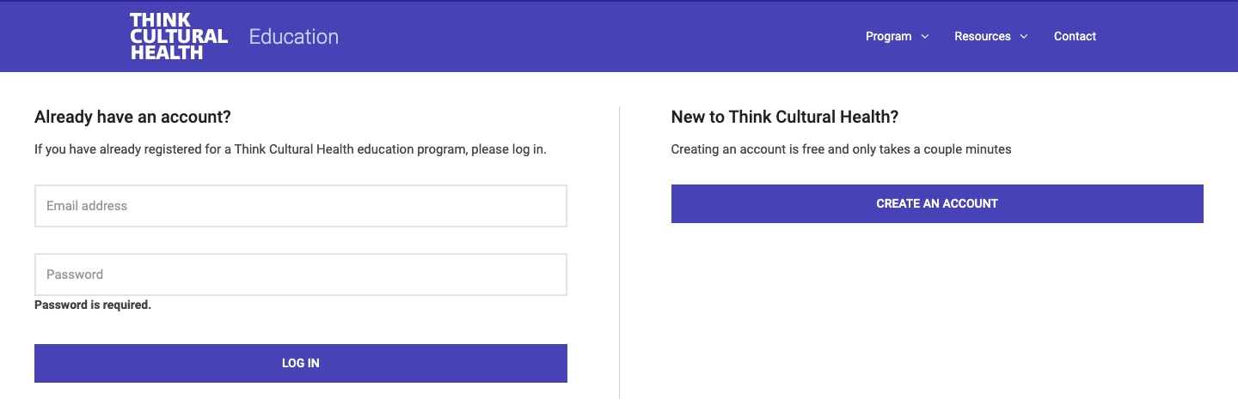
Access Information:
Login or register at the Think Cultural Health website
Choose Maternal Health Care Providers - Culturally and Linguistically Appropriate Services (CLAS) in Maternal Health Care program
Login, Read the Overview, Choose appropriate credit information & click Continue
Implementation strategies for the QI team
In a small group setting with an appropriate facilitator:
- Idea 1: Use the embedded “What do you think?” prompts to start discussion
- Idea 2: Use the embedded case studies in each module as a basis for a simulation
- Idea 3: Use the “What can I do next?” page and list of resources to encourage participants to identify and commit to further action and discussion.

Think Cultural Health:
Expanded Education Information
Each module incorporates self-reflective questions, “tell me more” options, case study, quiz, and next steps with a list of related resources. Glossary, Reference List, and Resource Library are also available.
Module 1, An introduction to CLAS in maternal health care, examines the role of CLAS in improving quality and eliminating disparities in maternal health care. This module focuses on the following concepts:
- CLAS and healthcare quality
- Cultural competency and cultural humility
- Racism and maternal health
  - Maternal health disparities
  - Social Determinants of Health
  - Institutionalized racism
  - Weathering
Module 2, Self-awareness, helps participants become more aware of their beliefs and values, as well as their privilege, power, bias, and stereotypes. The following concepts are highlighted:
- Social & cultural identity
  - Dominant/non-dominant social groups
  - Privilege
  - Power
- Implicit bias and stereotyping
  - Impact on clinical encounters
  - Awareness
  - Strategies to address biases and stereotypes
Module 3, Awareness of a patient’s cultural identity, presents the how and why of getting to know a patient’s cultural identity. Concepts highlighted include:
- Strategy of individuation
- Intersectionality
- Microaggressions
- Perceived racial discrimination
- History of racism
- Cultural humility
Module 4, Providing CLAS in maternal health care, explores ways to deliver respectful, compassionate, high quality care that responds to patients’ experiences, values, beliefs, and preferences. This module focuses on the following concepts:
- Review of cultural competency and cultural humility
- Person-centered care strategies
  - Effective communication strategies
  - Partnership building
  - Shared decision-making

