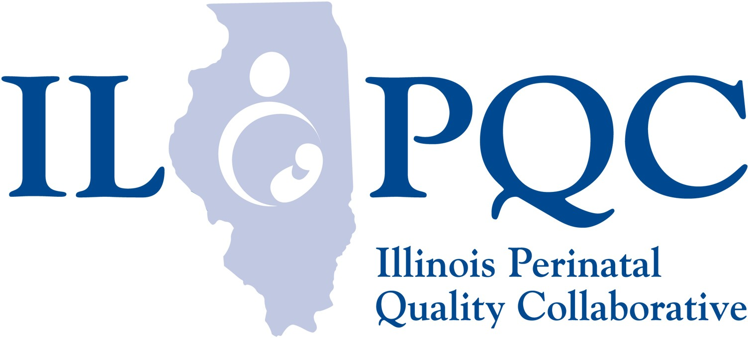

**Process Flow to Link Patients Who Screen Positive on SDoH Screening Tool**

A patient arrives for her NEW OB appointment or arrives on L&D



* Nurse communicate results to OB provider
* Nurse / OB provides linkage to needed resources and services ILPQC mapping tool, ILPQC SDOH Tip Sheets or NOW POW Community Resource Directory
* Social Work consult called as appropriate
* Nurse/OB document plan for follow up

After the screening tool is completed, the nurse document the results

Nurse reviews the SDOH screening tool with the pt. or provide it to the pt. to complete

Screen + Positive