CDC Hear Her Information Sheet
Description:
CDC’s Hear Her Campaign seeks to raise awareness of potentially life-threatening warning signs during and after pregnancy and improve communication between patients and their healthcare providers. The campaign’s objectives are to:
- Increase awareness of serious pregnancy-related complications and their warning signs.
- Empower women to speak up and raise concerns.
- Encourage women’s support systems to engage in important conversations with her.
- Provide tools for women and providers to better engage in life-saving conversations.

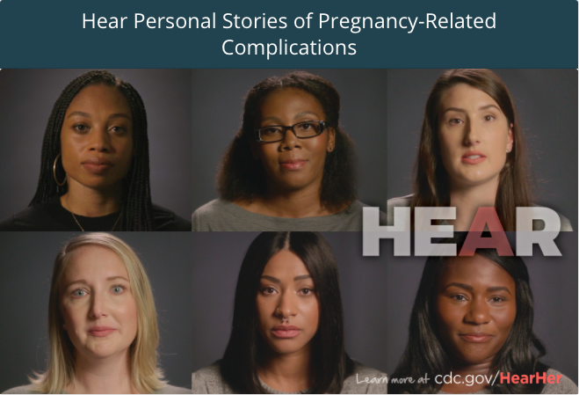
Education Content available:
ILPQC teams can navigate the main page of the Hear Her campaign linked below and find multiple resources within the website. Resources include links and information for patients, family and support members, and providers and are available in Spanish and English. Brief, compelling first-hand video accounts of patients who’ve experienced pregnancy or postpartum complications are included in the personal stories link.
Resources available include, links to:
- Personal Stories of Pregnancy-Related Complications
- ACOG’s Every Mom. Every Time. Campaign
- AWHONN’s POSTBIRTH Warning Signs Education Program
- AHRQ’s Improving Perinatal Care Toolkit
- Council on Patient Safety in Women’s Health Care’s Maternal Safety Bundles
- Resources and links for pregnant and postpartum patients
- Resources and links for support network of pregnant and postpartum patients

Access Information:
Find the main page of the Hear Her campaign linked here for available resources.
Implementation strategies for the QI team
- Idea 1: In a small group with appropriate facilitator, use the personal stories of pregnancy-related complications to build empathy & prompt discussion
- Idea 2: Have staff complete AWHONN’s POSTBIRTH Warning Signs program
- Idea 3: Use the resources to develop educational handouts for patients and families at provider offices and inpatient units

